About Hacking Club
Hacking Club is a platform to learn cybersecurity, an incredible resource if you don’t know where to start. In addition to vulnerable machines, you have access to classes and challenges to practice your skills and access to an exclusive community to play and challenge yourself.

The best part about Hacking Club is that it is very hands-on. If you are new to hacking, give it a try.

Introduction
This write-up refers to the GUEST machine. If you require support, please open a ticket in the support channel on the Discord server.

Nmap Scan:
We need to know which services are running in the background and which ports are open. So, we will use a tool called nmap.

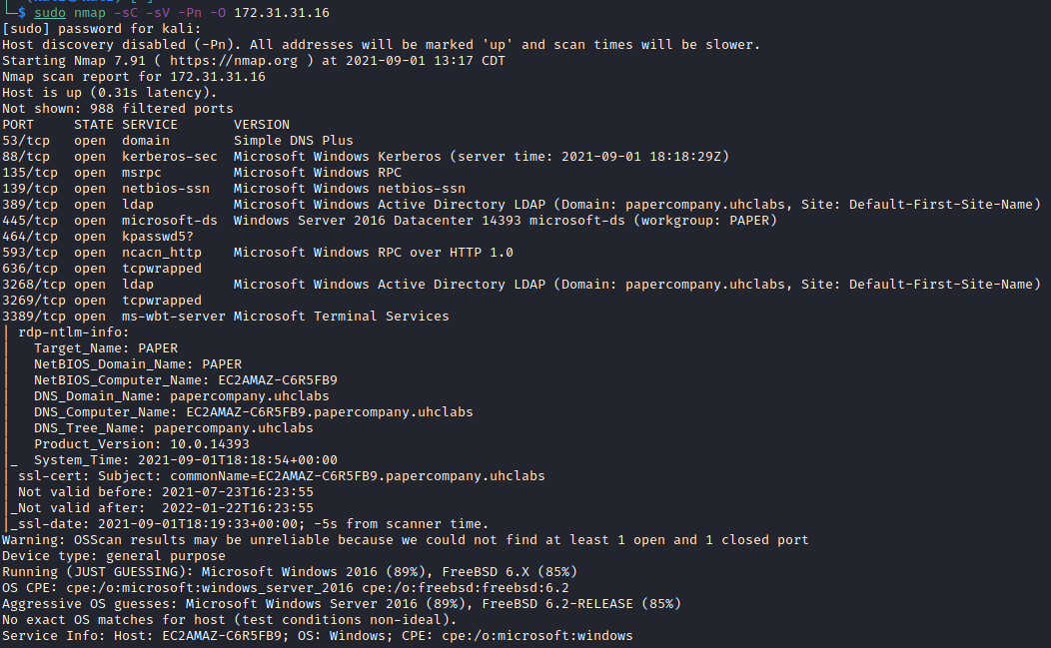
Adding entry papercompany.uhclabs to the hosts file:
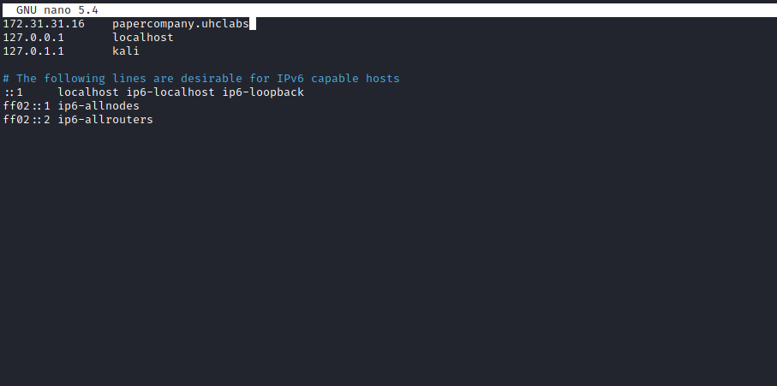
Let’s start with a basic enumeration using Enum4linux.
Enum4linux is a tool for enumerating information from Windows and Samba systems.
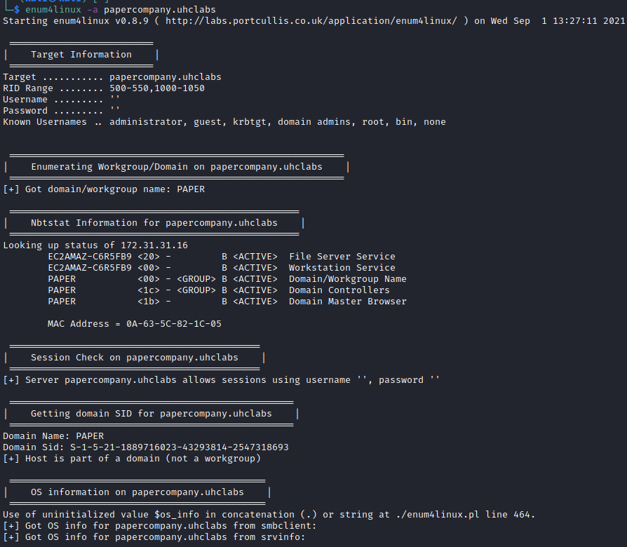
It did not return much, only some information about the AD Domain Controllers, so we will use another tool called Kerbrute.
Kerbrute is a tool to quickly brute-force and enumerate valid Active Directory accounts through Kerberos pre-authentication.
https://github.com/ropnop/kerbrute
I will use a username list that can be found at:
https://github.com/Sq00ky/attacktive-directory-tools/blob/master/userlist.txt
kerbrute userenum --dc papercompany.uhclabs -d papercompany.uhclabs userlist.txt -t 100
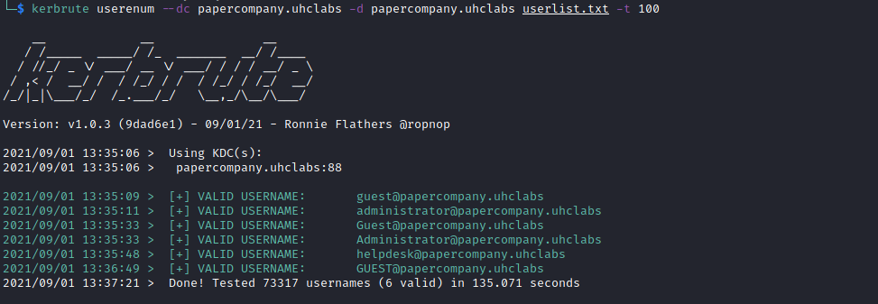
After user account enumeration is completed, we can try to abuse a feature within Kerberos using an attack method called ASREPRoasting.
ASREPRoasting occurs when a user account has the privilege “Do not require Kerberos preauthentication” enabled. This means the account does not need to provide valid identification before requesting a Kerberos ticket for the specified user account.

Impacket
Impacket includes a tool called GetNPUsers.py (located in Impacket/Examples/GetNPUsers.py) that allows us to query ASREProastable accounts from the Key Distribution Center.
The only thing required to query the accounts is a valid set of usernames that we previously enumerated using Kerbrute.
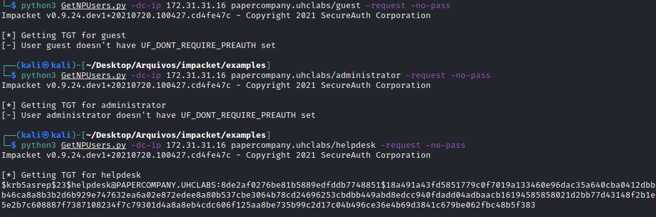
We obtained a Kerberos 5 AS-REP etype 23 hash belonging to the user helpdesk, so we will crack it using hashcat.
hashcat -- example_hashes (hashcat wiki)
https://hashcat.net/wiki/doku.php?id=example_hashes
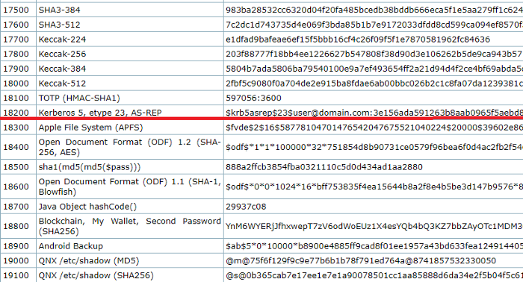

hashcat --force -m 18200 -a 0 hash rockyou.txt
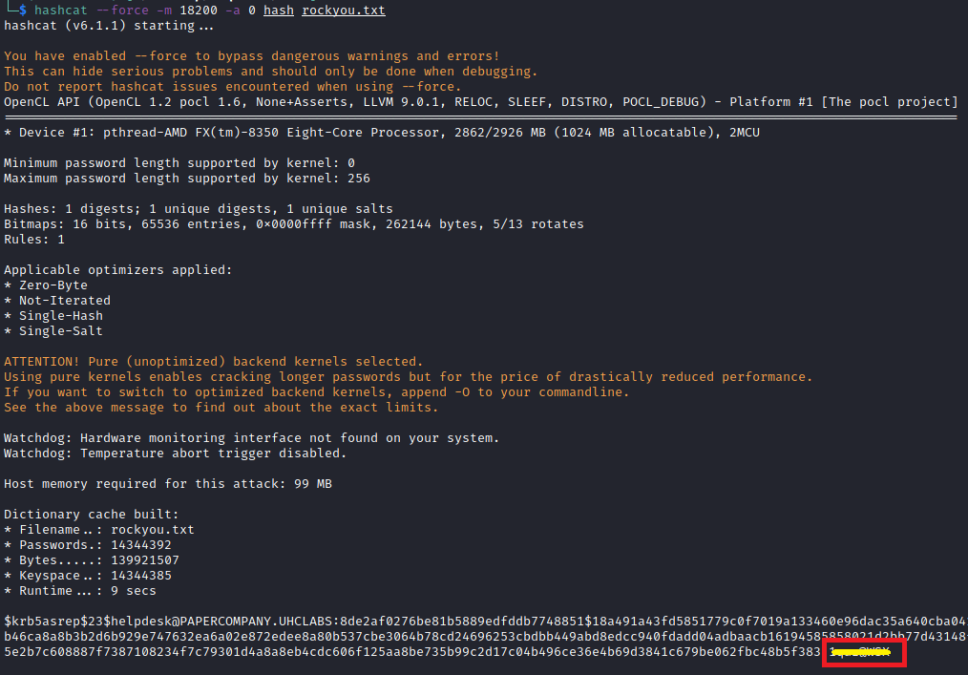
Now that we have a username and password, we can use Enum4linux again to enumerate further, and we can also try to obtain a shell on the system using Evil-WinRM, but first let’s enumerate again:
enum4linux -a -u "helpdesk" -p "<password>" papercompany.uhclabs

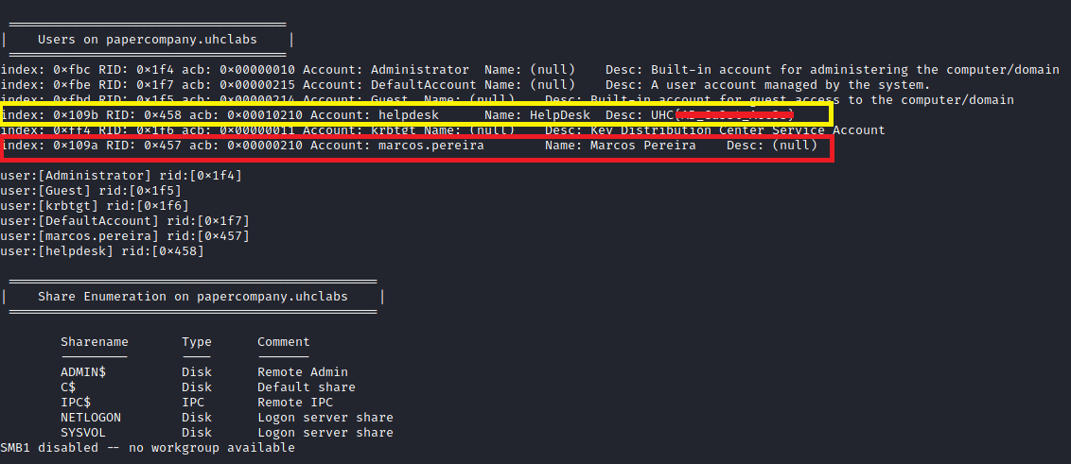
Here we have our first flag and a user → marcos.pereira
Let’s go Evil-WinRM
Evil-WinRM is the ultimate WinRM shell for hacking/pentesting.
WinRM (Windows Remote Management) is Microsoft’s implementation of the WS-Management protocol — a standard SOAP-based protocol that allows hardware and operating systems from different vendors to interoperate. Microsoft included it in their operating systems to make life easier for system administrators.
GitHub - Hackplayers/evil-winrm
https://github.com/Hackplayers/evil-winrm
We have access.
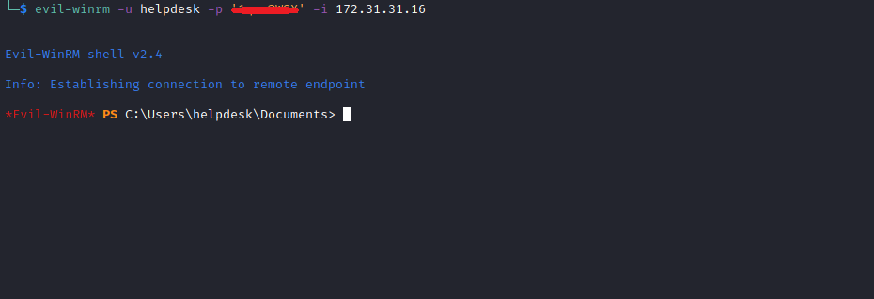

Root
Here I will use a tool called BloodHound.
BloodHound uses graph theory to reveal the hidden and often unintended relationships within an Active Directory environment. Attackers can use BloodHound to easily identify highly complex attack paths that would otherwise be impossible to identify quickly. Defenders can use BloodHound to identify and eliminate those same attack paths. Both red and blue teams can use BloodHound to gain a deeper understanding of privilege relationships within an Active Directory environment.
GitHub - BloodHoundAD/BloodHound: Six Degrees of Domain Admin
https://github.com/BloodHoundAD/BloodHound

How to install and use BloodHound:
Download it or install with:
https://youtu.be/gra9rU1-qY8
https://youtu.be/aJqjH3MsbLM

https://github.com/fox-it/BloodHound.py or pip3 install bloodhound

Lateral Movement and Privilege Escalation
Lateral movement is when an attacker leverages their current access rights to navigate through the environment. Privilege escalation is gaining higher access permissions. Attackers combine these two tactics to achieve their ultimate goal of stealing data or causing other damage to the organization.
Typically, when an attacker enters the environment, they begin reconnaissance to understand which resources they have access to and which accounts they may be able to compromise next. As they discover paths to elevate privileges, they gain access to even more data and resources. By repeating this cycle, they eventually strive to access the most valuable systems or data.
Let’s go BloodHound.
Linux - BloodHound 3.0.3 documentation
https://bloodhound.readthedocs.io/en/latest/installation/linux.html
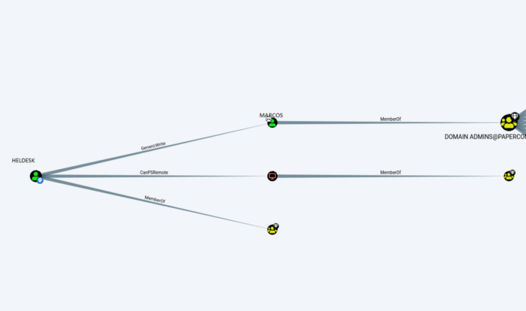
Here we can see that the user Marcos is part of the group DOMAIN ADMINS.
And our user HELPDESK@PAPERCOMPANY.UHCLABS has the ability to change the password of the user MARCOS.PEREIRA@PAPERCOMPANY.UHCLABS without knowing that user’s current password.
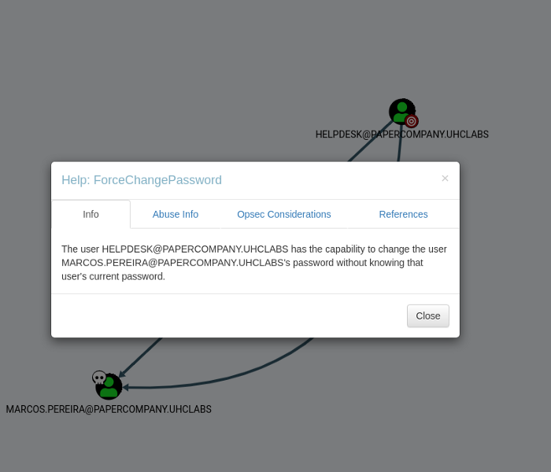

https://ariastark.hatenablog.com/entry/2021/03/22/213419

import-module ActiveDirectory
Set-ADAccountPassword -Identity 'CN=Marcos Pereira,OU=Paper,DC=papercompany,DC=uhclabs' -Reset -NewPassword (ConvertTo-SecureString -AsPlainText "p@ssword123_!@AB" -Force)
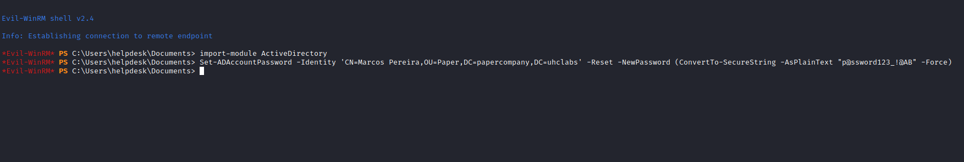

We successfully changed Marcos’s password. Now we will log into his account.
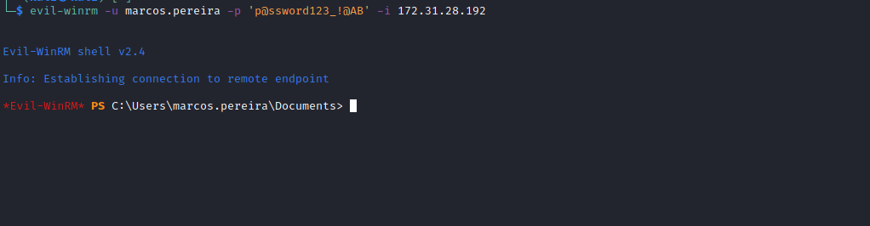
Since Marcos is part of the DOMAIN ADMINS group, we are able to retrieve the final flag located on the Desktop of the Administrator user =)
